**Detection Of The Light Using Photo Resistor**

**Batch no: 4**

**Name:**

2203A51L08 D. Neela Lohitha

**Lab Name:**

Internet Of Things

**Name of the Supervisor:**

**M. SHAILAJA**

Assistant Professor



**DEPARTMENT OF COMPUTER SCIENCE & ENGINEERING**

**CERTIFICATE**

This is to certify that the **INTERNET OF THINGS** Report entitled **“Detection Of The Light Using Photo Resistor”** is a record of bonafide work carried out by the student **D. Neela Lohitha** bearing Roll No(s) **2203A51L08** during the academic year 2022-25 in partial fulfillment of the award of the degree of ***Bachelor of Technology*** in **Computer Science & Engineering** by the Jawaharlal Nehru Technological University, Hyderabad.

**Lab In-charge Head of the Department**

**M. Shailaja M. Sheshikala**

**ACKNOWLEDGEMENT**

We express our thanks to Course co-coordinator **Mrs., Dr.** **Minakshmi Shaw , Asst. Prof.** for guiding us from the beginning through the end of the Course Project. We express our gratitude toHead of the department CS&AI, **Dr. M. Sheshikala, Associate Professor** for encouragement, support and insightful suggestions. We truly value their consistent feedback on our progress, which was always constructive and encouraging and ultimately drove us to the right direction.

We wish to take this opportunity to express our sincere gratitude and deep sense of respect to our beloved Dean, School of Computer Science and Artificial Intelligence, **Dr C. V. Guru Rao**, for his continuous support and guidance to complete this project in the institute.

Finally, we express our thanks to all the teaching and non-teaching staff of the department for their suggestions and timely support.

**Table Of Contents**

1. **List of the components 5 - 8**
2. **Working Principle 9 - 10**
3. **Code 11**
4. **Results 12**
5. **Discussions 13 - 14**
6. **Limitations 15 - 16**
7. **Future Work 17 - 18**
8. **Conclusions 19**
9. **References 20**

**List of the components:**

1. Photoresistor (LDR)
2. Resistor
3. Power Source
4. Arduino Board
5. Connecting Wires
6. Breadboard
7. LEDs
8. Voltage Regulator

**Detailed Descriptions of all components:**

1. **Photoresistor (LDR):**

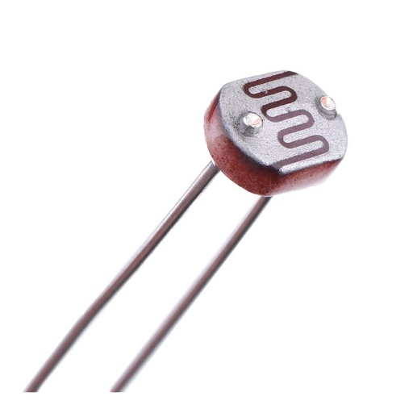

* A photoresistor, or light-dependent resistor (LDR), is a passive component that changes its resistance based on the intensity of light it is exposed to.
* It consists of a semiconductor material whose resistance decreases as the intensity of incident light increases.
* LDRs are commonly used in various applications such as light sensing, darkness detection, and brightness control.
* They are typically inexpensive and easy to use, making them popular for hobbyist projects and electronic circuits requiring light detection.

1. **Resistor:**

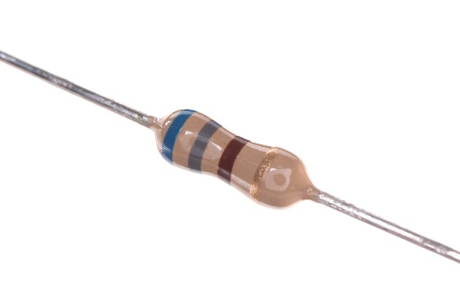

* A resistor is a passive two-terminal electrical component that opposes the flow of electric current.
* It is commonly used to create voltage dividers, current limiters, and to adjust signal levels in electronic circuits.
* Resistors come in various types including carbon film, metal film, and wire wound, each with different characteristics such as tolerance, power rating, and temperature coefficient.

**3. Power Source:**

* + The power source provides electrical energy to the circuit.
  + It can be a battery, a wall adapter, or any other source that supplies the required voltage and current for the circuit to operate.
  + The voltage and current rating of the power source should match the requirements of the components in the circuit.

**4. Arduino Board:**

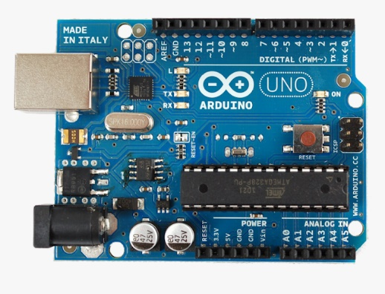

* + An Arduino board is a microcontroller-based development platform that provides easy-to-use hardware and software for building interactive projects.
  + It consists of a microcontroller unit (MCU), digital and analog input/output pins, USB interface for programming and communication, and other components necessary for operation.
  + Arduino boards are widely used in electronics projects due to their versatility, ease of use, and large community support.
  + The Arduino can read analog signals from the photoresistor using its analog input pins, process the data, and control other components based on the light level detected.

**5. Connecting Wires:**

* + Connecting wires are used to establish electrical connections between various components in the circuit.
  + They come in different lengths, gauges, and colors to facilitate wiring and organization.
  + Wires can be solid core or stranded, with each type having its advantages and disadvantages based on the application.

**6. Breadboard:**

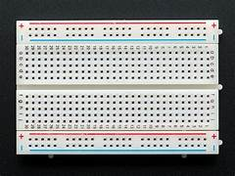

* + A breadboard is a solderless prototyping board used to build and test electronic circuits.
  + It consists of rows and columns of interconnected metal clips or sockets, allowing components to be easily inserted and connected without soldering.
  + Breadboards are reusable and allow for quick experimentation and modification of circuits during the prototyping phase.

**7. LEDs:**

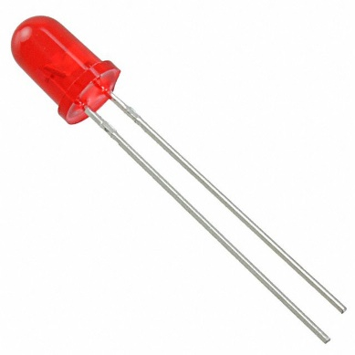

* + Light-emitting diodes (LEDs) are semiconductor devices that emit light when an electric current passes through them.
  + They come in various colors, sizes, and shapes, and are commonly used as indicators, displays, and light sources in electronic circuits.
  + In the context of a light detection project, LEDs can be used to visually indicate the detected light level or to provide feedback based on the circuit's operation.

**8. Voltage Regulator:**

* + A voltage regulator is an electronic circuit that maintains a constant output voltage regardless of changes in input voltage or load current.
  + It is used to ensure stable and regulated power supply to sensitive components in the circuit.
  + Voltage regulators come in different types such as linear regulators (e.g., LM7805) and switching regulators (e.g., LM2596), each with its advantages and disadvantages.
  + In a light detection project, a voltage regulator may be used to provide a stable voltage to the Arduino board or other components in the circuit, especially if the power source voltage is not within the desired range.

**Working Principle:**

The working principle of detecting light using a photoresistor revolves around the phenomenon of photoconductivity. Photoresistors, also known as light-dependent resistors (LDRs), are passive electronic components made of semiconductor materials such as cadmium sulfide (CdS) or cadmium selenide (CdSe). These materials exhibit a unique behavior where their electrical conductivity changes in response to the intensity of incident light.

In the absence of light, the semiconductor material within the photoresistor has a high resistance, hindering the flow of electric current through it. This high resistance is attributed to the electrons in the valence band being bound tightly to their respective atoms, making them immobile and preventing the flow of charge carriers (electrons or holes).

However, when light strikes the surface of the photoresistor, it transfers energy to the semiconductor material in the form of photons. These photons excite electrons from the valence band to the conduction band, creating electron-hole pairs. In essence, light energy is absorbed by the semiconductor material, promoting some of its electrons to higher energy levels where they can move more freely.

As a result of this absorption of light energy, the number of charge carriers (both electrons and holes) increases within the semiconductor material. This surplus of charge carriers facilitates the movement of electrical charge through the material, effectively lowering its resistance. In other words, the conductivity of the semiconductor material increases when it is exposed to light.

The change in conductivity of the semiconductor material is directly proportional to the intensity of the incident light. Higher light intensities result in a greater number of electron-hole pairs being generated, leading to a larger decrease in resistance. Conversely, lower light intensities produce fewer electron-hole pairs and a smaller decrease in resistance.

This change in resistance can be exploited in electronic circuits to detect and measure light levels. By incorporating the photoresistor into a voltage divider circuit, for example, the varying resistance of the photoresistor alters the voltage output of the circuit in response to changes in light intensity. This voltage signal can then be processed, analyzed, and used for various applications such as automatic lighting control, solar tracking systems, and security systems.

In summary, the working principle of detecting light using a photoresistor hinges on the ability of semiconductor materials to undergo photoconductivity, wherein the absorption of light energy leads to a change in electrical conductivity. This fundamental property enables photoresistors to serve as versatile sensors for detecting and measuring light levels in a wide range of applications.

**Code:**

const int LEDPin = 13;

const int LDRPin = A0;

void setup()

{

Serial.begin(9600); pinMode(LEDPin, OUTPUT); pinMode (LDRPin, INPUT);

}

void loop()

{

int LDRStatus = analogRead(LDRPin);

if (LDRStatus <= 500)

{

digitalWrite(LEDPin, HIGH);

Serial.print("Current Light Intensity Value is ");

Serial.println(LDRStatus);

}

else

{

digitalWrite(LEDPin, LOW); Serial.print("Current Light Intensity Value is ");

}

Serial.println(LDRStatus);

}

**Results:**

The results section outlines the findings obtained from the experiments or measurements conducted to detect light using a photoresistor. This typically includes:

**1. Light Intensity Measurements**:

Details of the light intensity readings recorded by the photoresistor under different conditions and lighting scenarios.

**2. Voltage Output:**

The voltage output of the voltage divider circuit containing the photoresistor, as measured across a fixed resistor.

**3. Calibration Data:**

Any calibration data collected to establish a relationship between light intensity and the corresponding voltage output.

**4. Response Characteristics:**

Information about the response characteristics of the photoresistor, such as its sensitivity, response time, and dynamic range.

**5. Comparison with Reference Standards:**

Comparisons with known light sources or reference standards to validate the accuracy and reliability of the measurements.

**6. Repeatability and Reproducibility:**

Assessment of the repeatability and reproducibility of the measurements to evaluate the consistency and reliability of the experimental setup.

**Discussions:**

The discussions section delves deeper into the interpretation of the results and offers insights into the underlying principles and implications of the findings. Key points addressed in the discussions include:

**1. Analysis of Data:**

Interpretation of the obtained data, including trends, patterns, and correlations observed in the light intensity measurements and voltage output.

**2. Effect of Environmental Factors:**

Examination of the impact of environmental factors such as ambient light conditions, temperature variations, and humidity levels on the performance of the photoresistor.

**3. Comparison with Theoretical Models:**

Comparison of the experimental results with theoretical models or predictions based on the physical properties of the photoresistor and its behavior under different lighting conditions.

**4. Limitations and Uncertainties:**

Identification of limitations and uncertainties associated with the experimental setup, data collection process, and measurement techniques employed.

**5. Optimization Strategies:**

Discussion of potential strategies for optimizing the performance of the light detection system, including circuit design improvements, sensor calibration techniques, and signal processing algorithms.

**6. Applications and Future Directions:**

Exploration of potential applications of the light detection system in various fields such as automation, robotics, environmental monitoring, and biomedical instrumentation. Additionally, suggestions for future research directions and areas for further investigation may be proposed.

**Limitations:**

**1. Nonlinearity:**

The relationship between light intensity and resistance in a photoresistor is often nonlinear. This can make it challenging to accurately measure light levels across a wide range of intensities, especially when precise quantitative measurements are required.

**2. Response Time:**

Photoresistors typically exhibit relatively slow response times compared to other light sensors such as photodiodes or phototransistors. This can limit their effectiveness in applications that require rapid detection of changes in light intensity.

**3. Spectral Sensitivity:**

Photoresistors have limited spectral sensitivity, meaning they may respond differently to light of various wavelengths. This can result in inaccuracies or inconsistencies in measurements when exposed to light sources with spectral characteristics outside their optimal range.

**4. Temperature Dependence:**

The resistance of a photoresistor is sensitive to temperature variations, with resistance decreasing as temperature increases. This temperature dependence can introduce errors in light intensity measurements, particularly in environments with fluctuating temperatures.

**5. Hysteresis:**

Photoresistors may exhibit hysteresis, where the resistance changes differently depending on whether light intensity is increasing or decreasing. This hysteresis effect can lead to discrepancies in measurements and complicate calibration procedures.

**6. Limited Dynamic Range:**

Photoresistors have a limited dynamic range, meaning they may not accurately detect very low or very high light intensities. This can restrict their applicability in environments with extreme lighting conditions or when a wide range of light levels needs to be measured.

**7. Aging and Degradation:**

Over time, the performance of photoresistors may degrade due to factors such as exposure to light, humidity, and mechanical stress. This can result in changes in sensitivity, response time, and overall reliability of the sensor.

**8. Directional Sensitivity:**

Photoresistors may exhibit directional sensitivity, with their response varying depending on the angle of incident light. This can lead to inaccuracies in measurements if the orientation of the sensor is not carefully controlled.

**Future Work:**

**1. Improving Linearity:**

Future research could focus on developing methods to improve the linearity of photoresistors, making them more suitable for applications requiring precise and accurate light intensity measurements across a wide range of intensities. This could involve novel material compositions, advanced fabrication techniques, or signal processing algorithms to linearize the response.

**2. Enhancing Response Time:**

Efforts to reduce the response time of photoresistors could lead to advancements in their applicability for dynamic light sensing applications. This might involve optimizing the material properties, device structures, or operating conditions to achieve faster response times without sacrificing sensitivity or stability.

**3. Expanding Spectral Sensitivity:**

Research aimed at broadening the spectral sensitivity of photoresistors could enable them to detect light across a wider range of wavelengths, opening up new opportunities for applications in areas such as spectroscopy, environmental monitoring, and biomedical imaging. This could involve incorporating additional materials or engineering the photoresistor structure to extend its sensitivity into ultraviolet or infrared regions of the spectrum.

**4. Temperature Compensation:**

Developing techniques for temperature compensation could mitigate the effects of temperature variations on the performance of photoresistors, enhancing their accuracy and reliability in diverse operating environments. This might involve incorporating temperature sensors into the photoresistor circuitry or implementing software algorithms to dynamically adjust the measurements based on temperature fluctuations.

**5. Integrating with IoT Platforms:**

Integration of photoresistors with Internet of Things (IoT) platforms and wireless communication technologies could enable remote monitoring and control of light levels in smart buildings, outdoor lighting systems, and agricultural applications. Future work could explore the development of IoT-compatible photoresistor modules with built-in connectivity and data logging capabilities.

**6. Miniaturization and Integration:**

Continued efforts to miniaturize and integrate photoresistor-based light sensing systems could lead to compact, low-power solutions for wearable devices, consumer electronics, and embedded applications. This could involve advancements in microfabrication techniques, MEMS (Microelectromechanical Systems) technology, and system-on-chip (SoC) integration.

**Conclusions:**

In conclusion, photoresistors represent a versatile and widely used technology for detecting light in various applications, ranging from simple ambient light sensing to complex automation systems. Despite their inherent limitations such as nonlinearity, slow response time, and temperature dependence, photoresistors offer advantages in terms of simplicity, low cost, and ease of integration.

Through careful calibration and characterization, photoresistors can be effectively utilized for tasks such as automatic lighting control, solar tracking, object detection, and environmental monitoring. However, further research and development are needed to address existing challenges and unlock the full potential of photoresistors in emerging fields such as IoT, wearable technology, and smart infrastructure.

By exploring avenues for improving linearity, enhancing response time, expanding spectral sensitivity, implementing temperature compensation, integrating with IoT platforms, and advancing miniaturization, future work can contribute to the continued evolution and innovation of photoresistor-based light sensing technologies, paving the way for new applications and opportunities in the years to come.

**References:**

1. Arduino - <https://www.arduino.cc/>

2. Arduino Tone Reference -

https://www.arduino.cc/reference/en/language/functions/advanced-io/tone/